**Duty Homogeneity**

***Work-flow to Duty Homogeneity***

There is currently one Optibus template



Use **Load Template** to set up the preference



You can repeat **Load Template** for additional instances of the template, but

it does not make sense to do it.

***Preference Overview***

This preference allows you to set duty homogeneity by route sign with a penalty that increases with homogeneity. If there are no changeovers during the duty then duty homogeneity is the same as vehicle route sign homogeneity.

See **Homogenic Vehicle Schedule** in particular, **Add Preference Dialog**.

***Templates Available from Optibus***

***Duty Homogeneity***

**Purpose:**

As described in the Overview. **Prerequisites:** None. **Opening Dialog:**

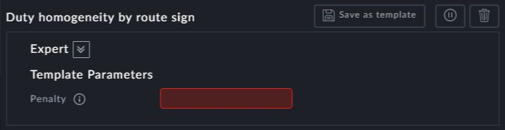

**Points to Note:**

**Penalty**: The penalty field is mandatory. The penalty level determines the level of homo- geneity.